|  |  |
| --- | --- |
| Course Name | ITD 2313 – Script Programming |
| Instructor | Rene Hurst |
| Student Name | Bryce Lakey |
| Due date | 9/29/2024 |
| Grade | <grade earned here> |
| Grading Comments | <instructor comments here> |

**Textbook Exercises**

Page 54:

Page 55:

1.

2.

3.

4.

5.

Page 56:

Page 57:

1.

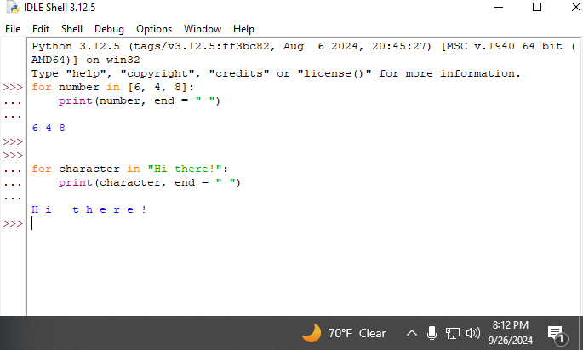

2.

3.

Page 58:

Page 59:

1.

2.

3.

4.

